Title of Procedure: *(Service Break Rate Report)*

SOP Owner: *(Zhaofeng Shang)*

SOP Effective Date: *(Leave blank for now)*

Report Frequency: *1st week of every month*

Report Publish Date: (*Self Serv.)*

Revision Number: Draft

1. Business Reason for Report:

This report combines ODS part and Fact part data to represent the Total WU([HeartSmart_Whole_Unit_Repair]) order and Total PE([HeartSmart_Priority_Exchange]) order, calculates the Cumulative rate and Annualized rate of service break on both side as well. The aim of report is to show the extent of total orders in total sales by mark.

Heartland data is stored in the SQL server via interface, not a manual upload.

2.Procedures:

**Step 1:**

Find the Model in the Cognos:



And then into the Services🡪Service_Work

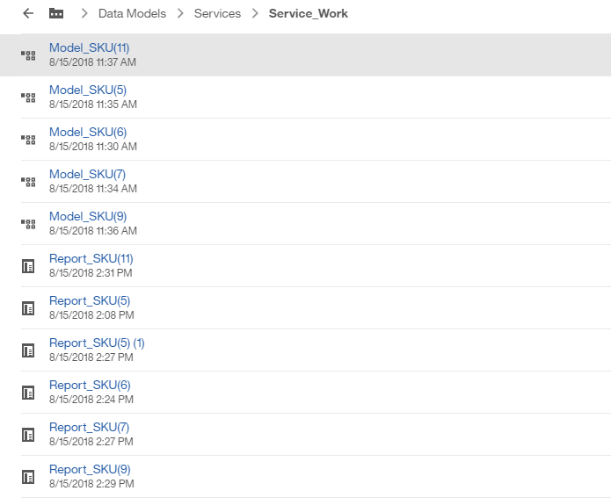

There are five different models according to different length of “SKUMark”.

**Step 2:**

run those five files as the Excel.

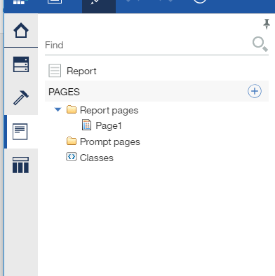

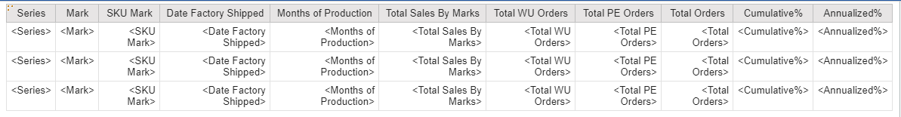

The calculation:

Cumulative% : Total Orders/ Total Sales By Marks

Annualized% : Total Orders/ Total Sales By Marks/ Months of Production* 12

Date Factory Shipped: [C].[Service_Break_Rate_test_2].[ProductMark].[FactoryShipDate]

Months of Production: _MONTHS_BETWEEN( _add_months(current_date, -1 ), [Date Factory Shipped] )

Total Sales By Marks: total([C].[Service_Break_Rate_test_2].[uv_ODS_Billing_Material_Qty].[INV_Qty] for [SKU Mark] )

Total WU Orders: count( distinct [C].[Service_Break_Rate_test_2].[HeartSmart_Whole_Unit_Repair].[Order_Number] for [SKU Mark])

Total PE Orders: count(distinct [C].[Service_Break_Rate_test_2].[HeartSmart_Priority_Exchange].[Order_Number] for [SKU Mark] )

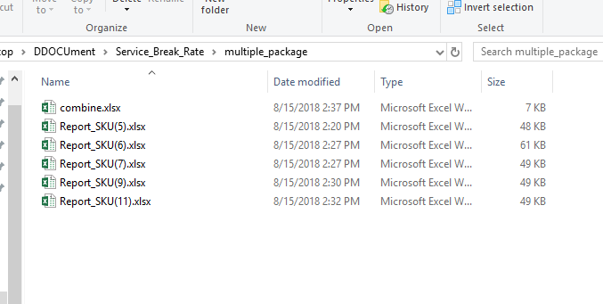

**Step 3:**

Use the VBA code or manually to combine those files together.

1. create a new empty excel
2. If you don’t have Developer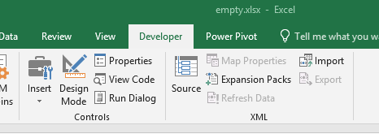

Go to File 🡪Option🡪Customize Ribbon🡪Developer

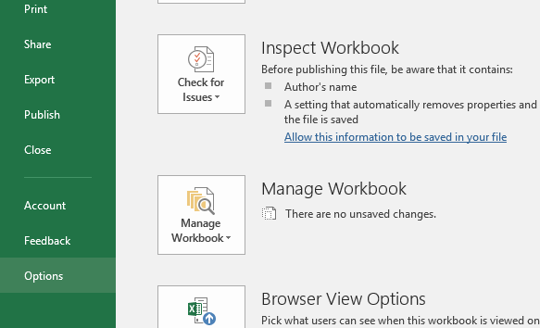

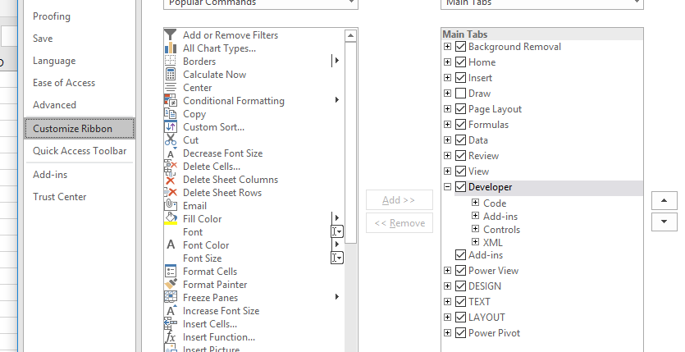

1. Right click the tab “Sheet1”, then go to “view code”.

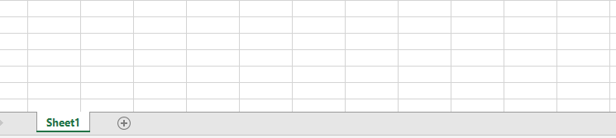

1. Go to the “Insert” at the top of picture, and then insert “Model”

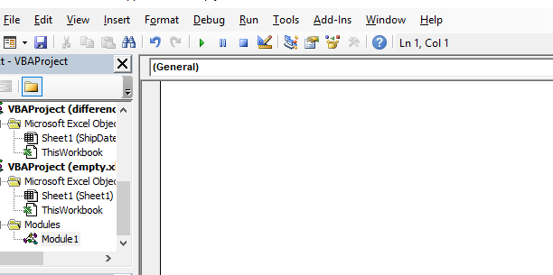

1. Add the code below into the model, then press “F5” in the keyboard.

Sub combine_excel()

Dim FileOpen

Dim X As Integer

Application.ScreenUpdating = False

FileOpen = Application.GetOpenFilename(FileFilter:="(Microsoft Excel*.xlsx),*.xlsx", MultiSelect:=True, Title:="combined excel")

X = 1

While X <= UBound(FileOpen)

Workbooks.Open Filename:=FileOpen(X)

Sheets().Move After:=ThisWorkbook.Sheets(ThisWorkbook.Sheets.Count)

X = X + 1

Wend

ExitHandler:

Application.ScreenUpdating = True

End Sub

1. Select the file you want to combine ,click Open.

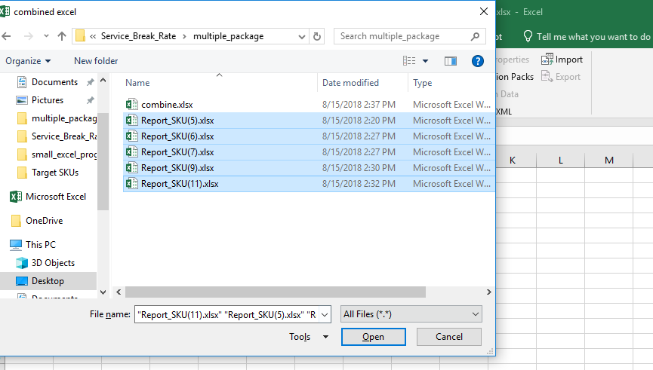

1. Delete the empty tab “Sheet1”

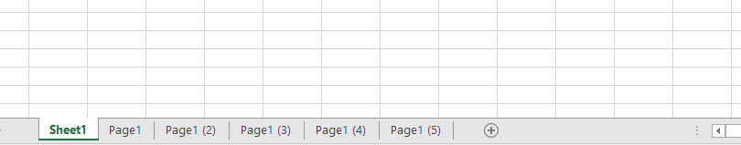

Then combine all tabs into one excel sheet:

1. Right click the one of tab and go to the View Code, create a new model as above.

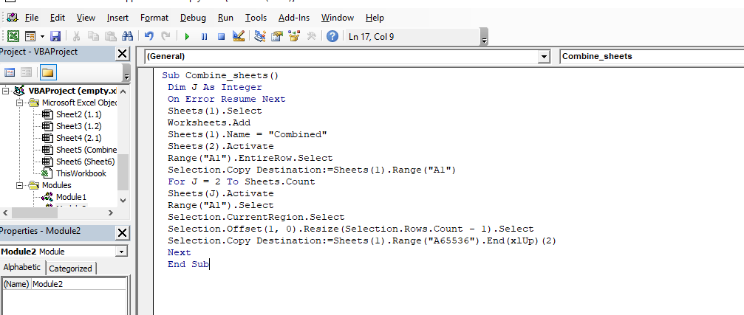

Sub Combine_sheets()

Dim J As Integer

On Error Resume Next

Sheets(1).Select

Worksheets.Add

Sheets(1).Name = "Combined"

Sheets(2).Activate

Range("A1").EntireRow.Select

Selection.Copy Destination:=Sheets(1).Range("A1")

For J = 2 To Sheets.Count

Sheets(J).Activate

Range("A1").Select

Selection.CurrentRegion.Select

Selection.Offset(1, 0).Resize(Selection.Rows.Count - 1).Select

Selection.Copy Destination:=Sheets(1).Range("A65536").End(xlUp)(2)

Next

End Sub

1. Then press “F5” to run, we can get the combine tab as below. It only leaves one header in the file.

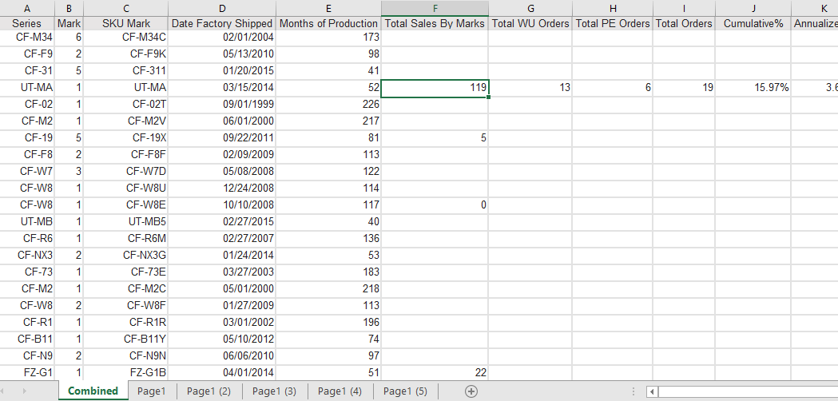

3. isolate the Combined tab into a new excel, just keep the final result.

3.Recipients:

To: <Hobson, Duane> [duane.hobson@us.panasonic.com](mailto:duane.hobson@us.panasonic.com);

4.Appendix (use this area for any additional comments, definitions etc.)

To save the file with Macro, need save as this version.

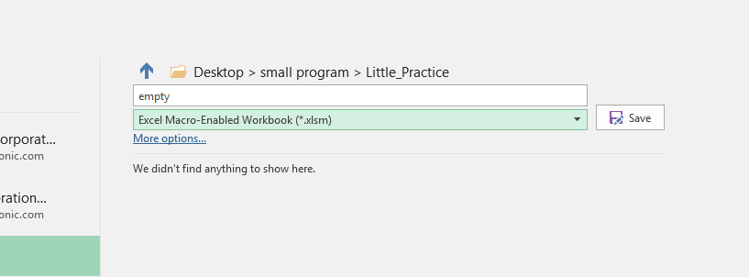

Or, you can just isolate the result into another file.

These are the rules employed in the Auditing process to identify “pure” in-warranty orders:

* Based on Repaired, Reported and Actual Code values (False/Positives, where there was *no real work done* on the unit)
* Mixed In-Warranty values within an order (Excluded). Only where all line items are ‘T’ are included.
* Mixed model numbers within an order (Excluded)
* Order number prefix values of LONR, HSI and SWPR (Excluded)
* Orders with Arbitrator model numbers (Excluded)

The Model Structure in Cognos:

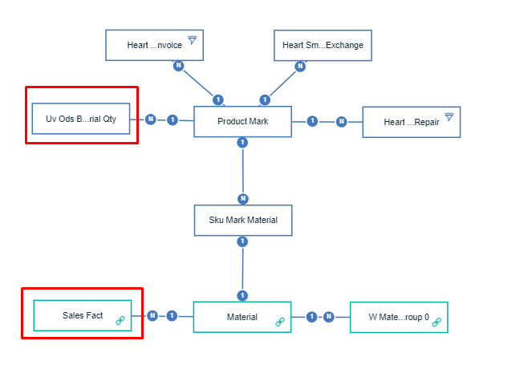

The model combined the Sales Fact(future) and ODS(old) data together and grouped by Product Mark, create the “Months of Production”, “Total Sales By Marks”, “Total WU Orders”, “Total PE Orders”, “Total Orders”, “Cumulative%”, “Annualized%” columns, in order to show the final result in the Service Break Rate Report.

Source tables for Breakrate:

[PSCBI_STG].[STG_XLS].ProductMark PM

[PSCBI_STG].STG.HeartSmart_Whole_Unit_Repair Sales

[PSCBI_STG].STG.ODS_BILLING Sales

[PSCBI_STG].STG.HeartSmart_Priority_Exchange Sales

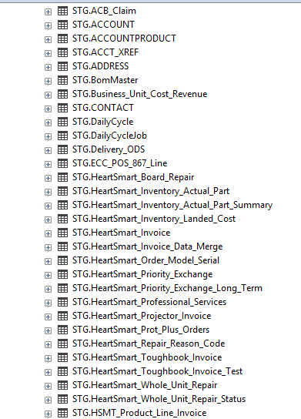

Skumark for minimum(date)

Fact: 10.1.2013--7.1.2018

Ods:11.15.2017